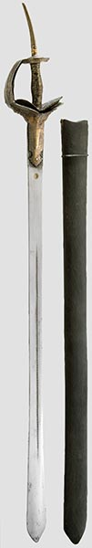
Hermann Historica
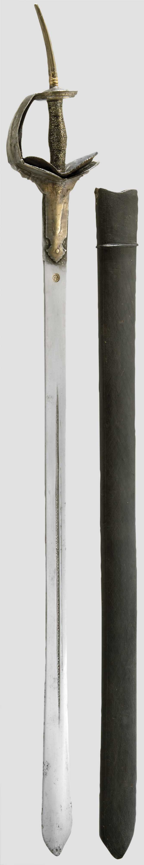

Hermann Historica

