British Sword Inspection & View Marks - Updated
R Wilkinson Latham

Inspection and View marks as we know them started in around 1788 when instructions were issued for stamps or punches to be made. These were to be issued to Board of ordnance viewers for military goods. Many of these were for firearms but some were obviously intended to be used on swords as well.
Joseph Witton was paid for having made viewers marks and the document in the PRO states there were 7 designs, small crown and cross sceptres (For firearms), crown alone and a crown above the figures 1,3,4,6 and 8. the price was 1/6d (one shilling and sixpence) (PRO WO.52/34 p 135)
Witton made four each of the crown and figure punches. (The missing numbers 2,5 and 7 seem to suggest that these punches existed already and were in good condition or never issued)

Examples of View marks are:
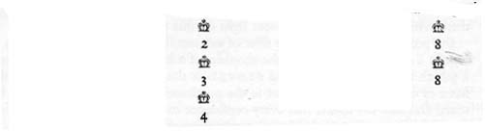
By the 1840’s a different system of view marks was in use.
This assigned a viewer a number and an area or manufacturer. These new marks or punches consisted of a crown over a letter over a number.

The letter marks identified the place or manufacturer These were:
B = Birmingham | E=Enfield
BR= Birmingham Repair | L=Liege (British Inspector)  F= French (British Inspector)
S= Solingen (British Inspector) | To those letters already in use was added in 1887  Crown 49 and W, and later  W=Wilkinson sword Company.

Around 1880/82 the design changed to have a crown over a number of a letter.

After 1884, more marks were added, especially to Cavalry Sword.
Date | Mark
2/12 1885 – Improved testing | VM on right Flat. When hilkted VM on back of blade. When complete M and Viewers mark on right flat, date on left
20/11/1889– Improved testing | Striking machine test. Marked X on right flat – Blades already in manufacture marked X with dot beneath
15/1/1890– Improved testing | Marked MX above shoulder (Mole)  Marked EX above shoulder (Enfield)  Marked WX above shoulder (Wilkinson)

The Wilkinson sword Company inspectors mark changed again in the late 1950’s to be a circle with the letters around the edge T W S C (The Wilkinson LP Company) and in the centre the inspector’s number. This was supplied as a metal stamp for blades and a rubber stamp for the paperwork!
