Etymology, Taxonomy & Nomenclature

Etymology: What’s in a name?? Sometimes nothing, but sometimes a whole family history. In Scandinavia the concept of a family name was unknown until the early 20th century, when householders were encouraged to register a surname for entry on the census/electoral register. Before that the family name consisted of a string of names from the male line: Johansonofericsonofolafsonof…… or a combination of forename and place name, which changed if the family moved to another village or region.

The origins of the word for billhook and those for other edge tools, allows us to trace their ancestry, or that of the peoples that make up the country where they are found. The word ‘billhook’ although frequently used today was not in common usage until the mid to late 19th century. It is used in Francis Blakie’s ‘A treatise on Hedges and the Management of Hedgerow Timber’ in 1828, but rarely in John Claudius Loudon’s ‘Encyclopaedia of Farming’ (1829) or Encyclopaedia of Gardening’ (1830), and not in Henry Stephens’ ‘The Book of The Farm’ (1852). Both these latter authors use the more common term hedge-bill or hedging bill, or just the word bill (also switching bill and cutting bill) as did Samuel Johnson in his 1773 ‘Dictionary of the English Language’. Early catalogues, such as Joseph Smith’s ‘Explanation or Key to the Manufactories of Sheffield’ (1816) also used the term ‘bill’ (and reserve ‘hook’ for reaping hooks, pruning hooks and furze hooks). Generally hedge-bill refers to a long handled bill, used with two hands (c.f. a slasher) and a bill for one-handed use is called a hand-bill.

The word billhook⁽¹⁾, sometimes and, in my opinion, erroneously written as two words, bill hook, or joined with a hyphen as bill-hook, is shown in OED the as having the following origin:

Bill-hook: (bi-l,huk) 1611 [f. bill sb.¹ ] A heavy thick knife or chopper with a hooked end, used for pruning etc.
Bill: (bil) sb.¹ [OE. bil = OS. bil, OHG bil (MHG. ; but G. bille fem., axe) :- WGme. bilja 1. A kind of sword mentioned in OE. poetry. 2. An obsolete weapon carried by soldiers and watchmen varying in form from a concave blade with a long handle, to a kind of concave axe with a spike at the back and its shaft ending in a spearhead; a halberd ME. 3. Short for BILLMAN 1495. 4. An implement having a long blade with a concave edge (cf. BILL-HOOK), used for pruning, cutting wood etc. OE. 5. A pickaxe - 1483.

The earliest known reference in the Oxford English Dictionary (OED), above, is 1611, and for a synonym, hook-bill, it is 1613. Shakespeare ca 1580 to 1600 used bill (Richard 111 1,4; Romeo and Juliet 1,1 & As you like it 1,2), and his less well known contemporary Sir Philip Sidney in ‘The Countess of Pembroke’s Arcadia’ ca 1580 also used bill; hedging bill and forest bill.

In England it is still variously known as a billhook (bill-hook or bill hook) but also as a bill or handbill (hand-bill) or just a hook in some english counties and hedging-bill in others. The OED also gives hack, and in parts of Dorset and Devon it is still known as a hacker and in parts of Kent as a brishing (brushing?) hook. Double edged bills, i.e. those with a second blade at the back, are referred to as broom-hooks by some makers. Those used on a chopping block are often known as a block-hook. As a boy the author knew it only as a chopper. In other languages there are often many names for the same tool, e.g in France it is serpe, serpette, poudo, goyard, gouet and many others.

A small billhook, typically used by thatchers or coppice workers for splitting hazel gads and pointing the smaller piece of wood is known as a spar hook or spit hook. (Spars or broches are used by thatchers to fasten the thatch to the roof, and before use they are bent into a U shaped staple with an ingenious double twist which separates the fibres and allows them to bend without breaking them.)
Billhooks are also referred to as pruning hooks (also pruning knife, especially if of the folding type) although these are generally smaller than the average sized bills. Some makers also offered gentleman's and lady's billhooks, which were usually highly polished and fitted with more ornately turned handles, often made of imported hardwood, antler or horn. One such is the Milton Hatchet, which is double edged and unusual in having a single bevel on the back blade, similar to that found on a chisel.

On the author’s original web site www.heytesbury.freeserve.co.uk it was erroneously stated that:

A billhook is a short cutting tool (bill) with a curved nose (hook), and the majority of billhooks, english or foreign, are easily recognisable as being of this shape.

Even Professor White in his scholarly work on roman agricultural tools falls into a similar trap, stating:

The term billhook indicates that the blades are ‘hooked’ (i.e. curved) in profile and that in addition they have the characteristic projection at the top of the curved blade, known as the ‘beak’ (Lat: rostrum, a bird’s beak). ⁽²⁾

While many billhooks are of this shape, others in the UK have straight blades (e.g. the Rodding or Block hook patterns) or even convex blades (e.g. Rutland or Hertfordshire patterns).

Looking at the etymology of this using the world for billhook in other languages gives a different interpretation:

German: hackbeil (also hackmesser, haumesser, hippe, häpe, heep etc)

Dutch: hakbijl (also hakmes, snoeimes, etc)

Hook would thus appear to derive from hack (German) or hak (Dutch) and bill from beil (German) or bijl (Dutch) thus also giving some clues as to the origins of the invaders of Anglo Saxon Britain as well as the origin as of the name, hook-bill or billhook.

Bill thus does not refer to the shape of the tool resembling the beak or bill of a bird, and hook does not relate to the shape of the blade with a hooked end. Bill, beil or bijl thus go back to the OED definition giving its origin as axe or short sword. Hook, hack or hak also refer to the action of the tool for cutting or chopping. In German the word for the verb ‘to chop’ is hacken (noun hacke or hacker) and in Dutch it is hakken (noun hakker). The word for hook is haken (German) or haak (Dutch).

Thus billhook (or hook-bill c.f. hackbeil also spelled as hackebeil or hakbijl) describes the function of the tool as a chopping tool (sword, axe or short knife), rather than its ‘hooked’ shape (further confirmed by the alternative names of hackmesser (German) and hakmes (Dutch) where messer/mes means knife, hence chopping knife. In both languages (and also in Italian, Hungarian and Polish) the word for a billhook can also be synonymous with that for a meat cleaver.

Having traced the ancestry of the word, however it is obvious that in english the hook part of the word has now changed its meaning to describe the tool itself, not its function. Hook is frequently on its own to indicate a billhook and also other tools of a similar shape such as the spar hook, the reap hook, the fagging hook, the bean hook etc. Also calling the beak of the tool by its alternative name of bill, has also meant that the way in which the word is now used differs greatly from its origins – language evolves, and users thus refer to the bill (of the hook), meaning the pointed beak.

As the billhook was in use in England long before the Saxon invasions we may need to look even further back to find what it was called before the Romans invaded, and it became known as the falx in Latin (note falx also means sickle and scythe, so it was usual to give it an adjective to describe its use further, e.g. falx arboraria, falx sylvatica or falx putatorem, for pruning trees, or falx vinitoria, for pruning grape vines). Possibly in pre-Roman times it was called the biwlg (pronounced bilygau) as in Welsh or the fidba (feeva) in Gaelic??? (Note also the Welsh for axe is bwyell (pronounced bwyeill or bwyellau) and in Gaelic it is biail (beeal) – similar in sound to bill, beil and bijl???).

In other languages, e.g. French, Spanish and Italian it is also possible to trace the evolution of the word for billhook, but in these languages the variety of dialect names vastly exceeds those commonly found in the UK. Some interesting historical links can be seen that do not match modern, often 20th century, national boundaries. In both Sardinia (an Italian island) and the Basque region of France/Spain the word puda is commonly used – in France it becomes poudo, in Spain podón, and in Portugal podäo, podal or podoa. In Italy it is generally referred to as a roncola or pennato, but in the Pavia region (Lombardy) it is known as a pùdarö ⁽³⁾. All are probably derivations of the Latin amputare (to prune) hence putatio (pruning) and putator (a pruner, i.e. one who prunes), from which the modern Italian potare (to prune) and Spanish podar derive. Probably the result of oral transmission of language in dialect forms, possibly a relic from the time when only the clergy could read and write (the principal religion was Catholicism and Latin was the language of the church and of scholars), it is easy to understand a change in pronunciation from puta to pota to poda to podo.

Taxonomy: A billhook is a tool, but not all tools are not billhooks: so it is also necessary to be able to place any artefact in its correct taxonomic place. The following grouping may be a start:

Iron and Steel
Tool
Hand tool
Edge Tool
Blade in line with handle
Used in agriculture; forestry etc
Used for cutting or chopping

The problem is that there is not just one simple taxonomic definition to use: we could also use:

Object with a practical function
Object used to work another material
Object made from more than one material
Object with a blade for cutting or chopping
Object made of iron or steel
Object with a handle

One has only to look at the various museum collections that hold billhooks or pruning hooks to see the various ways in which a tool of this type can be classified (or mis-classified), or where do you place the billhooks used in dutch carpenters’ shops or french cooperages that are not used for agriculture, forestry or viniculture, or the many types of billhook that have an integral handle made from iron or steel, or the polish tasak and the italian mannaia which are both used equally as a butchers meat cleaver as they are for chopping wood???

How then does one define a billhook, or translate the word accurately into or from a foreign language?? For the purpose of this work the broadest possible definition will be used: from the very small to the very large; from those with the cutting blade in line with the handle, to those where it is at an angle; those with integral handles made as part of the tool, to those with a handle made from another material, fitted by tang, socket, rivets, glue or even moulded on in plastic or rubber; those with a single blade; those with two (or even more blades, or parts thereof); those with other tools attached, or that form part of another tool – in short anything that remotely resembles what in England we generally take to be a billhook; those that other cultures and languages name as being a billhook (and anything else that the author wants to include in the non-definitive book on the subject that he thinks should be included…).

As part of the reason for this book is to avoid mis-definition, and the incorrect naming of other non-billhook tools as billhooks, later chapters will mention other tools that could be (and frequently are) incorrectly identified. Thus a billhook is not just a tool for cutting green wood, but where, as in other cultures, it has other uses (e.g. in the Balkans they are used for harvesting maize; in the West Indies large billhook type tools are used for cutting a form of grass, sugar cane, and in France a sugar beet knife is called a serpe à betterave, i.e. a billhook for beetroot) then it will be included and discussed.

Nomenclature: The roman author Lucius Iunius Moderatus Columella (AD 4 - ca. AD 70) who after a career in the army (he was tribune in Syria in AD 35) took up farming, wrote a twelve volumes treatise on farming, De Re Rustica. This has been completely preserved and together with a smaller book on trees (De Arboribus) forms the most important sources on Roman agriculture . He is the first author to describe the vine dressing knife or pruning hook in detail, ref Book 4 Chapter 25:
XXV. Est autem sic disposita vinitoriae falcis figura, ut capulo pars proxima, quae rectam gerit aciem, culter ob similitudinem nominetur; quae flectitur, sinus; quae ab flexu procurrit, scalprum; quae deinde adunca est, rostrum appellatur; cui superposita semiformis lunae species securis dicitur. Eiusque velut apex pronus imminens mucro vocatur. Harum partium quaeque suis muneribus fungitur, si modo vinitor gnarus est iis utendi. Nam cum in adversum pressa manu desecare quid debet, cultro utitur; cum retrahere, sinu; cum allevare, scalpro; cum incavare, rostro; cum ictu caedere, securi; cum in angusto aliquid expurgare, mucrone. Maior autem pars operis in vinea ductim potius quam caesim facienda est. Nam ea plaga quae sic efficitur, uno vestigio allevatur. Prius enim putator applicat ferrum, atque ita quae destinavit praecidit. Qui caesim vitem petit, si frustratus est, quod saepe evenit, pluribus ictibus stirpem vilnerat. Tutior igitur et utilior putatio est quae, ut rettuli, ductu falcis, non ictu conficitur.
1 Now the shape of the vine-dresser's knife is so designed that the part next to the haft, which has a straight edge, is called the culter or "knife" because of the similarity. The part that is curved is called the sinus or "bend"; that which runs on from the curve is the scalprum or "paring-edge"; the hook which comes next is called the rostrum or "beak," and the figure of the half-moon above it is called the securis or "hatchet"; and the spike-like part which projects straight forward from it is called the mucro or "point." Each of these parts performs its own peculiar tasks, if only the vine-dresser is skilful in using them.
2 For when he is to cut something with a thrust of the hand away from him, he uses the culter; when he is to draw it toward him, he uses the sinus; when he wishes to smoothe (sic) something, he uses the scalprum, or, to hollow it out, the rostrum; when he is to cut something with a blow, he uses the securis; and when he wants to clear away something in a narrow space, he makes use of the mucro. But the greater part of the work in a vineyard must be done by drawing the knife toward you rather than by hacking; for the wound which is made in this way is smoothed with one impression, since the pruner first puts his knife in place and so cuts off what he has intend to cut.
3 One who attacks the vine by chopping, if he misses his aim, as often happens, wounds the stock with many blows. Therefore that pruning is safer and more advantageous which, as I have said, is accomplished by the drawing of the knife and not by striking. ⁽⁴⁾
The most commonly reproduced image of the vinitoriae falcis or falx vinitoria is shown below:

6
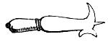
2
5
1
3
7
4

 | Latin | English | French | Italian | Spanish | German ⁽⁵⁾
1 | Culter | Knife | le Coutre | il Coltello | el Cuchillo | das Messer
2 | Sinus | Bend | le Pli/le Creux | l’Incavo | la Curva | die Krümme
3 | Scalprum | Paring blade | le Couteau | la Roncola | Corbada ?? | das Schabmesser
4 | Rostrum | Beak | le Bec | il Becco | el Pico | der Schnabel
5 | Mucro | Spike/Point | la Pointe | il Punta | la Punta | der Dolch
6 | Securis | Hatchet | la Hache | l’Ascia/ la Scure | el Hacha | die Axt
7 | Capulus | Handle | la Manche | il Manico | el Mango or  la Maceta | das Heft
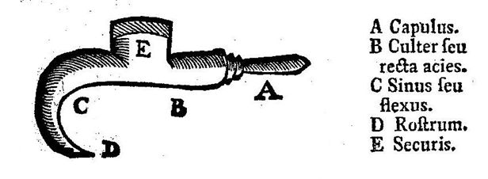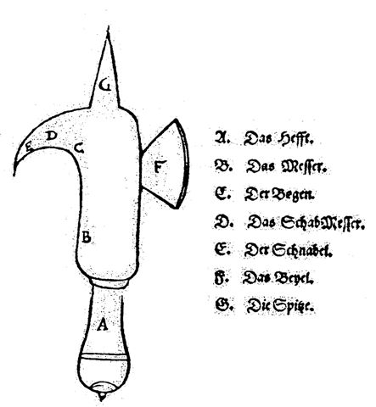
Images from Columella – De Re Rustica
(left) Dichter Jacques Vanière (1664-1739), Toulouse (right) 1538 edition (Strasbourg) ⁽⁶⁾

It is interesting how later authors have added to Columella’s original latin text. In Vanière’s edition culter has become culter seu recta acies (knife or straight cutting edge) and sinus is sinus seu flexus (bend or curve). The translation to German in the 16th century also uses old spellings, and words that differ from those currently in common usage: Das heffe has become das heft, der begen is now die krümme (although dictionaries still show alternatives such as bogen or biegung), das beyel is now die axt (although beil remains in common usage) and die spitze is der dolch. There is no direct translation for schabmesser into english, but the verb schabe means to scrape or shave, the nouns schaber and schabhobel mean scraper and spokeshave respectively. It thus show how problematical it can be to translate words accurately from one language into another, especially where in most languages a word may have multiple or alternative meanings. The problem is made worse when the word in common usage does not match the dictionary definition e.g. the common word for handle in Spanish is (el) mango, but technically this applies to a handle for a saucepan or kettle, and the word that refers to a tool handle is (la) maceta. Even in English we frequently interchange words, e.g. blade or iron are both used for a plane blade (something the Romans also did as Columella often referred to a falx as a ferrum).

Naming of the parts of the billhooks varies from country to country, not just because of the different languages, but also because there are cultural differences in how they are classified. In England and Germany they are broadly grouped into single edge (einschneidige häpen) and double edge billhooks (zweischneidige häpen), whereas in France they class them as single hook (serpe à un seul croc) and double hook (serpe à deux crocs), the latter having a slight secondary hook at the heel of the blade. They tend to ignore either the second blade on the back, or the various secondary hooks (crochet or agrafe) used to push branches away from, or to pull them towards, the user. In Italy single edged billhooks are usually known as roncole (singular roncola) and double edged ones as pennati (singular pennato), similarly in Hungary as kacor and metszőkés respectively.

English | French | German | Italian | Spanish
Blade | la Lame | die Klinge | la Lama | el Filo or la Hoja
Handle | le Manche | das Heft | il Manico | el Mango ( or la Maceta ??)
Tang | la Soie | die Angel | la Punta | ?
Ferrule | la Virole | die Zwinge | la Ghiera | ?
Socket | la Douille | die Tülle | la Legatura | Enchufe
Back | le Dos | der Rücken | il Dosso or la Parte Posteriore | el Dorso
Cutting Edge | le Tranchant | die Schneide | il Taglio | el Trinchante
Hook (front) | le Croc | der Schnabel | il Becco (Anteriore) | ????
Hook (back) | l’Agrafe or  le Crochet | der Haken | il Gancio | el Gancho
Edge Tools | la Taillanderie | das Schneidegerät | gli Attrezzi da Taglio | la Cuchillería
(Hand) Tool | l’Outil | das (Hand)gerät or Werkzeug | l’Atrrezzo | el Util or  la Herramienta
Cutting or Edge Tool | l’Outil Taillant | das Schneidegerät | l’Attrezzo Tagliente | la Herramienta de Corte
Iron | le Fer | das Eisen | il Ferro | el Hierro
Steel | l’Acier | der Stahl | l’Acciaio | el Acero
Wood | le Bois | das Holz | il Legno | la Madera
Pruning | la Taille | der Schnitt | la Potatura | la Poda
Single edge(d) | à un (seul) tranchant | Einschneidig
Double edge(d) | à deux tranchants | Zweischneidig
Bevel |  | die Schmiege
Single bevel |  | Einseitig geschärft
Double bevel |  | Zweiseitig geschärft
Concave | Concave/Courbé | Konkav
Convex | Convexe/Ventré | Konvex
Straight | Etroite | Gerade
To Cut | Couper | Schneiden |  | Cortar
To Chop | Hacher | Hacken
To Prune | Tailler | Beschneiden |  | Podar
To Split | Fendre | Spalten

The situation is frequently confused by the large number of billhook type tools found. The shapes of blade vary considerably, as does the size; thickness and profile, the method of fixing the handle and the intended usage. The similarity with sickle type of tools is obvious, and hybrid types for cutting wood (c.f. french faucille à bois) or woody materials abound. Originally it is likely that a stone axe, a flint knife and a sickle (reaping hook) made of pieces flint glued to a wooden holder would suffice to make a shelter, butcher meat and harvest grain; and stone tipped spears and flint arrow heads gave a means to hunt and kill: but as hunters became farmers, and nomads settled into a fixed location, time became available to develop better tools and weapons. With the discovery of metals, first bronze and later iron, it became possible to develop a range of more sophisticated weapons such as swords, and it is not a big step to see how a curved sword would also be an ideal tool for clearing land, harvesting grain or cutting wood, and vice-versa.

The origins of most of these types of tools are lost in the sands of time, but we can gain some glimpses into their history and development by looking at archaeological finds that can be dated with some accuracy. By looking at the types of natural environment the people lived in; the foundations of their buildings; their burial sites; the remains of the food they ate and the detritus they threw away, it is possible to build up a picture of life in the Iron Age: to study it in detail and, by using experimental archaeology, to recreate it. Before the third Roman invasion of Britain by Claudius in 43 AD a wide range of shapes and sizes of sickles and billhooks were being used:

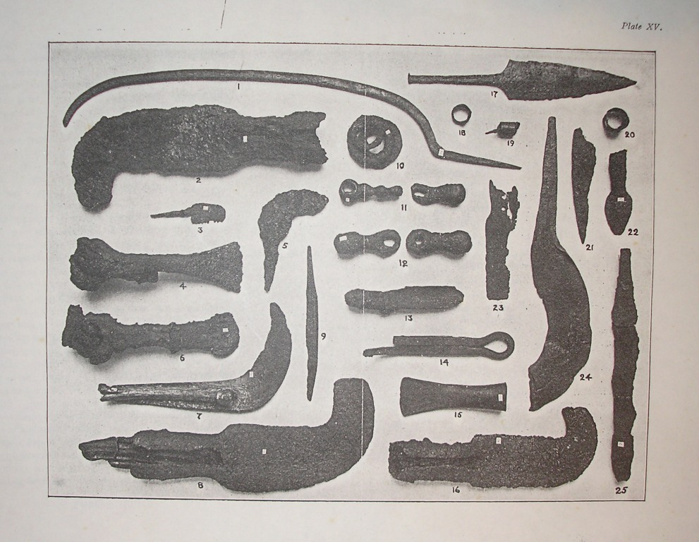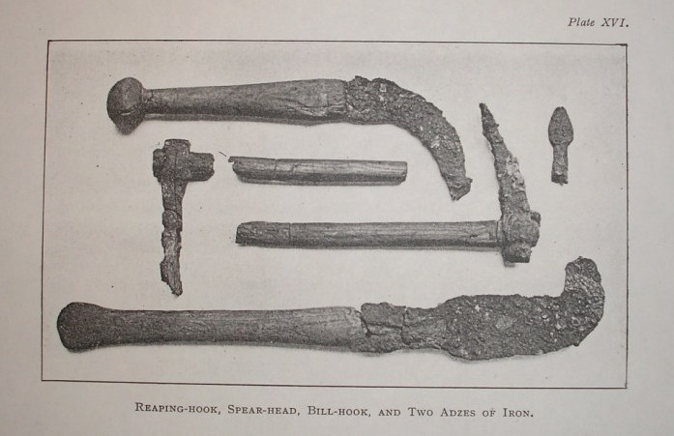

Pre-Roman era tools from the Glastonbury Lake Villages ⁽⁷⁾ (Somerset, South West England). Note: different sizes and shapes of blades (sickles and billhooks) and the use of both tanged and socketed handles. Similar shaped billhooks with a socket for the handle are still found in Morocco in the 21st century.

The Iron Age in Britain lasted from about 650 BC to 43 AD, when following the Romans conquest, it became a province of Rome, a state that continued to about 400 AD. With the Romans came improvements in iron working and deep vein mining of minerals and ores, allowing a much greater output of iron. New designs of more efficient tools and weapons would have followed, although in rural areas the old patterns probably survived long into the Dark Ages. At the end of the Roman occupation the population of Britain is believed to have been about three times bigger than it was when William the Conqueror invaded in the 11th century. A population of this size would have needed an efficient infrastructure to provide food, which in turn would have required a wide range of agricultural hand tools.

From very basic tools, a wide range of blade shapes, with differing uses developed. Large long handled brushing hooks could be used to clear woodland, billhooks to harvest undergrowth and create coppices, smaller billhooks to prune, cleave, split and sharpen stakes and poles for use in gardens, fences and buildings; yet others to prune fruit trees and vines; tiny ones for harvesting grapes and fruit – sickles and reaping hooks to harvest a wide range of crops: first grasses and wild cereals, but later corn, wheat, oats, barley and maize.

By the early 19th century, when industrialised manufacture had started to replace the village blacksmith, the range of tools and variations seemed endless, and the distinctions between the boundaries blurred. By the middle of the century edge-tool catalogues showed hybrid billhook-axes; billhook-slashers; sickle-billhooks; billhook-sickles; pruning hooks or multifunction tools such as the Game-keeper’s Friend, a combined slasher, axe, billhook and spade. In their 1930’s catalogue the french edge tool makers, Talabot, showed over 200 different regional patterns of french billhooks, but stated that they held the patterns for over 3000 types, and would make any other shape to order upon submission of a paper template or drawing⁽⁷⁾…..

Classification of tools is thus not an easy matter, and it is frequently difficult, if not impossible, to accurately identify many tools or to be certain what material they were used on, or even in what trade. For museums and collectors the situation is often worse: does one classify a tool by its shape; its thickness; its size; the material it was designed to cut; the use to which it was being put when it was collected; where it came from etc etc… A muddled situation, often further confused by a lack of specialist knowledge or understanding by the collector or curator. Even in the best of museums errors are found, and the author has recently (2009) seen in the V&A in London a german brass handled cooper’s tool mislabelled as a butcher’s cleaver. A simple mistake to make, but the blade has a single bevel, like a wood chisel, not a double bevel as usually found on knives and cleavers. A single bevel causes the blade to move sideways - not something you want to happen when you are holding a joint of meat with your other hand…. Looking through on-line museum collections, such as the Dutch National Ethnological Museum at Leiden (Museum Volkenkunde), or the Musée du quai Branly in Paris, one can see billhook types of tools mis-classified as sickles, reap hooks, weapons or axes.

One example of a billhook type tool that remains difficult to classify are those made by the Mangbetu tribe of the Northern Congo (Zaire) in the 19th century. They, and some of the tribes from the surrounding area, were skilled metal workers and produced iron artefacts of the highest quality. The ‘tools’ they produced are variously described as weapons (throwing knives), ceremonial or ritual artefacts, even as currency – but rarely as cutting (or agricultural) tools. They have the weight, shape and size of a typical European billhook, and similar ‘tools’ made by neighbouring tribes are frequently described as such. What sets the Mangbetu knives apart is the quality of the craftsmanship, the decoration on the blade and the often highly ornate and carved handles (often made of ivory, or wood bound by silver wire). They are thus an expensive and high status object, seemingly reserved for the king and his chieftains. However many hundreds, possibly thousands, survive, far more than one would expect from a society that at most consisted of 40,000 persons and was really only established in the region for a century (by the beginning of the 20th century the skill of making such tools had largely disappeared, and the quality of those made as tourist souvenirs in the second half belied the skill of those who made them a hundred years earlier). They would thus appear to have had a wider prevalence among the population than expected. They may, of course, have been made for trade and thus migrated outside the region of influence of the Mangbetu, but most of the neighbouring tribes had their own smiths, and their own shapes and styles of ‘tool’. European traders and explorers brought many examples back to Europe (mainly to Belgium), but few studied the tribe in their everyday life. Seeing their king holding one when seated on his throne may not have been a true representation of the usage. One has only to look at some of the highly decorated 18th and 19th century billhooks from Italy, Austria and Hungary to see how a common, everyday tool can be of exceptional quality. The Mangebtu knives thus remain something of an enigma for ethnologists as well as the amateur researchers and historians of tools….. and, of course, ceremonial or ritual tools or weapons have much higher value than mere hand-tools…

In other languages the situation is not made any easier by dictionary entries, dialects, and changes of usage, As mentioned above the same word is used in Dutch (similarly in Spanish and Polish) for meat cleavers and fire-wood choppers as well as agricultural billhooks and vineyard pruning hooks. In English-Spanish dictionaries a billhook is often listed as a podadora (although podón is more commonly used in Spain) – however if you look up podadora (or podadera) on the internet you will not find many entries corresponding to billhook, but there will be lots for secateurs (tijeras), the tool invented in France that from 1860 onwards started to replace them for pruning of grape vines, and even more entries for motor-mowers and motorised brush cutters. The word tijeras also has multiple meaning, including: scissors, long-handled loppers and sheep or grass shears. Confusingly alternative names for podón include hoz (sickle) and guadaña (scythe) – possibly because in some regions the billhook has a narrow curved blade c.f. the French faucille à bois. Guadaña is also commonly used as an alternative name for a motorised brush cutter or strimmer (see podadora, above).

In Greek Κλαδευτήρι (kladeuteri), which is the word for pruning hook or billhook, is now used for secateurs; hedge trimmers and chainsaws. The meanings of many words for hand tools have thus evolved away from their original usage… as a result dictionaries are not always the best source for the correct word when translating (something this work hopes to correct for the billhook and allied tools).

As well as the official dictionary word(s) there are often many regional names, resulting from the many local languages, dialects, patois that have contributed to the language base. For example in France one finds French, German, Flemish, Italian and Spanish spoken in the border regions, but also Alsacien, Basque, Breton, Norman, Provençal (Occitan) and Savoyard as well as many other regional languages and dialects. This will be discussed in more detail in later chapters and word lists given in the appendices.

There are other possible areas of research for etymologists to discover how phonetically similar words for the same or functionally related tools appear in apparently unrelated languages. For example, the word for billhook in French, serpe, and the words for sickle in Finnish, sirppi; Polish, sierp; Czech, srp; and in Russian*, cerp (серп) sound very similar in the spoken languages; and the Greek for a single-edge socketed billhook, kasara (Κασάρα), is almost the same as the word for the same tool in Finnish, kassara. Possibly the answer is simple: e.g. the Russian for secateur is sekator (cекатор) i.e. a simple phonetic translation from Roman to Cyrillic alphabet, so maybe the Finns also borrowed the Greek word. However, it is also phonetically similar to the words koser, kosir, coser, cosser, coster, choser – names for the billhook in the various countries of the Balkans, so more probably, the answer lies deeper and reflects population movement centuries, or even millennia, ago….

This study does not attempt to answer all the queries and questions, but it will hopefully point the reader in the right direction, and create topics for further study, research and debate…

* footnote: the Russian for billhook (or pruning hook) is секач or кривой нож (literally curved or bent knife) – but is секач itself a contraction of cекатор, and thus a ‘new’ i.e. 19th or 20th century word, or did the word secateur originate from Russian for pruning tool??

References :

(1) F.Horace Teall – Compound Words and Phrases, Funk and Wagnalls Co, 1892

(2) K.D. White – Agricultural Implements of the Roman World, CUP, 1967
(3) http://www.comune.garlasco.pv.it/Informazioni/Garlasco%20e%20il%20suo%20dialetto.pd
(4) http://penelope.uchicago.edu/Thayer/E/Roman/Texts/Columella/de_Re_Rustica/4*.html
(5) C.A.Wimmer – Die Häpe (Zandera Band 23 (2008), Nr 1 ISSN 0940-9920)
(6) C.A.Wimmer op cit
(7) Somerset (Details to be added)
(7) Catalogue (Details to be added)

